

SENIORS SECTION ANNUAL GENERAL MEETING MINUTES - 25 Feb 2026
Cttee members present:
Will Polland – Captain (Chair) (WP)
Ross McFarlane – Vice-Captain (RM)
Mick Hempstock – Immediate Past Captain (MH)
John Frost - External Fixtures Secretary (JF)
Co-opted Cttee members present:
Clive Robinson (CR)
Ron Austen (RA)
Section members present:24
Apologies for absencereceived from :
Laurie Burt (Internal Fixtures Sec), James Newsom (Treasurer), Steve Patterson, Francesco Pecora, Bob Lippitt, Andy Bennett, Gareth Rowlands, Dave Stiff, Brian Simpson and Ken Stiff.
Item No | Subject | Discussion | Actionee | Action By
1 | Welcome and Introduction | At 1400 WP opened the meeting, welcomed the members and thanked them for their support.  WP called for all present to be upstanding and observe a minute’s silence in remembrance of those Club Members lost to us in the previous year.  Apologies for Absence were noted and detailed above.
2 | Bob Chapman Trophy | The prizes for the 6th Winter Stableford were presented prior to the meeting.  Peter Grimes successfully defended his title and was, again, awarded the Bob Chapman Trophy.
3 | Vote to accept previous Minutes | The minutes of the previous AGM, having been distributed before the meeting, were accepted as a true record of events (Prop Will Polland, 2^{nd–}Chris Chapleo).
4 | Captain’s report | WP addressed the meeting and stated that:  It has been an honour and a privilege to be your Seniors Captain and I thank everyone who has helped me during my year.  We have played 20 Matches against other Clubs and have been reasonably successful, more detail on that when John Frost presents his report, but importantly we have managed to field a full team for every match. My thanks go to all those who have supported the Match Teams.  I am however, disappointed with the support for our Internal Competitions.  We must be careful that we make efforts to use all the tee times allocated to us for our competitions before the DoG and The Club have reason to question our tee time allocations and I therefore request that all Section Members make greater efforts to support Ross and our Internal Competitions in the coming year.  I have, on behalf of the Section and with the support of our Committee, made representation to the Club Committee with regard to greater recognition and consideration of our Section especially with respect to trophy and honours board accommodation and in discussions and consultations regarding important matters that affect us all... for example Slow Play.  I can report that we have received kind and generous support in the matter from the Club Committee and especially the current Captain (Graham Tetley) and are now invited to attend the Club Committee as a non-voting member.  My chosen charity for this year was Cystic Fibrosis and I am proud to report that the total raised was £1465.  I must thank all Section Members for their support in this and most especially will mention Neil Tilley for using his knowledge and business contacts and Chris Chapleo whose efforts and determination in selling raffle tickets always makes a significant contribution to our efforts.  I am arranging an appropriate presentation ceremony for this donation.  And so finally, thank you all for making my year so enjoyable and successful.  Thank you.
5 | Internal Fixtures Secretary Report | LB Apologies accepted. WP presented Laurie Burt’s Report to the meetingas detailed in Appendix 1. to these Minutes.  WP also advised the meeting that he is currently updating the Seniors Website with relevant Competition data.
6 | External Fixtures Secretary Report | JF Presented his report to the meeting as detailed in Appendix 2 to these minutes.
7 | Treasurer’s Report | JN apologies accepted, WP presented his report to the meeting. See Appendix 3.  Pete Rushby was thanked for auditing the accounts.
8 | Vote to accept Treasurer’s Report | The accounts, having been distributed before the meeting, were accepted as a true record of the section’s financial activity and position (Prop –Bob Dasey, 2^{nd –}Carl Denis).
9 | Appointment of Seniors Captain | Ross McFarlane was appointed as Seniors Captain for 2026/27
10 | Appointment of Seniors Vice Captain | Clive Robinson was appointed as Seniors Vice Captain for 2026/27
11 | Election of Cttee Officers | The following officers were elected into post by RM for the 26/27 season:  Treasurer - James Newsom - Proposed by WP, 2nd Barry Baker.  Internal Fixtures Sec - Laurie Burt – Proposed by Neil Tilley, 2nd Bob Adcock.  External Fixtures Sec - John Frost – Proposed by Bob Dasey, 2nd Jim Kirman.  Section Secretary - no nominations.
12 | Proposals & AOB – (Items submitted in writing by 4th Feb 2026 only) | No Proposals or matters for discussion had been submitted.
13 | Captain’s Address/Meeting Close | RM addressed the meeting:  First of all, thanks to Will for his Captain’s year, I think he ran a tight ship and kept the profile of the Seniors as high as possible. Also, well done Will on the money you raised for Cystic Fibrosis. Thanks too should go to the committee which keeps the Seniors wheels turning so smoothly.  Thanks to you all for supporting me in my year as Captain. I’m still not sure how it happened, but Will and Ron can be very persuasive when required! I hope to continue the work Will has done this year, and to raise the standing of the Seniors section even higher. As some of you will be aware, we have been allocated a seat on the Club Committee. It’s non-voting but gives us a chance to keep up to date with what is going on and to voice an opinion on how the club is run.  My chosen charity for the year is Motor Neurones Disease. The MND Association funds work to finding life-changing treatments through research, and to help those who suffer from the disease to live what’s left of their life with some dignity. It is as brutal as that – there is no cure for MND – yet.  My goal for the inter-club matches is to win more than we lose which would be an improvement on last year. As some of you know my one appearance as stand-in Captain resulted in an 8-0 drubbing at Lincoln – things can only get better!!  Numbers playing in internal competitions seem to have dropped slightly of late, so I hope that the Seniors competitive instinct will see entries increase during 2026.  Thanks once again for accepting me as Captain, and especial thanks to Clive for agreeing to be vice-captain. Hopefully between us we can make Elsham Seniors a force to be reckoned with locally.  We close with a vote of thanks to Mick Hempstock for all the work he has done on the Committee over the last few years.  Meeting was closed at 1430 hrs.
14 | Date of Next Meeting | TBA.
15 | Open Forum | RM opened the floor to general discussion.  A summary of this is included below as Appendix 4 to the minutes.

Appendix 1. to AGM MOM 250226

1. Internal Fixtures Secretary’s Report.
INTERNAL COMPETITIONS AGM REPORT
Firstly, can I apologise for not attending the meeting, I have enjoyed being internal competitions secretary and wish to carry on in the position if so elected. Competitions went well last year with numbers averaging 30% of the membership entering the comps. All but one Trophy was played for and that was The Barry Baker Trophy which has been addressed for this season. The calendar has been set for 2026 and is posted on the Seniors noticeboard, October – December have not yet been populated by the club. A dairy will hopefully be displayed on the Seniors website in the near future? I would like to thank the membership for the support given to me last year and it has been a pleasure.
Respectfully
Laurie

Appendix 2. to AGM MOM 250226
EXTERNAL FIXTURE SECRETARY REPORT 2025-2026
We had 20 matches throughout season, winning 4, losing 11 and drawing 4.
One match at Brough was played as a Team AMAM.
It is nice to win, however playing different courses, enjoying other players company is the main reason for these matches. It is also a good advertisement for Elsham Golf Club to have so many players visiting the course and the financial benefit it brings.
We managed to fulfil all matches with full teams, thanks to all Senior Members that stood in at the last minute.
The Jim KirmanTrophy was held for all Senior Members that played in team matches, the Trophy was won by Ross McFarlane.
Next seasons matches have all been arranged with the same teams as last year. Unfortunately due to club policy changes some home matches will be starting at 1100 hrs instead of 0900 hrs. I do hope this change will not affect getting the required number of players for each match.
We will using the same system as last season, V1 to register your availability for each match and then WhatsApp for information and team selection.
For any new or existing member that is not registered on the V1 Club Teams and wishes to play team matches please email myself: John Frost,frostj18@googlemail.com
with Name and mobile phone number
JOHN FROST

Appendix 3. to AGM MOM 250226
1. Treasure’s Financial Report.

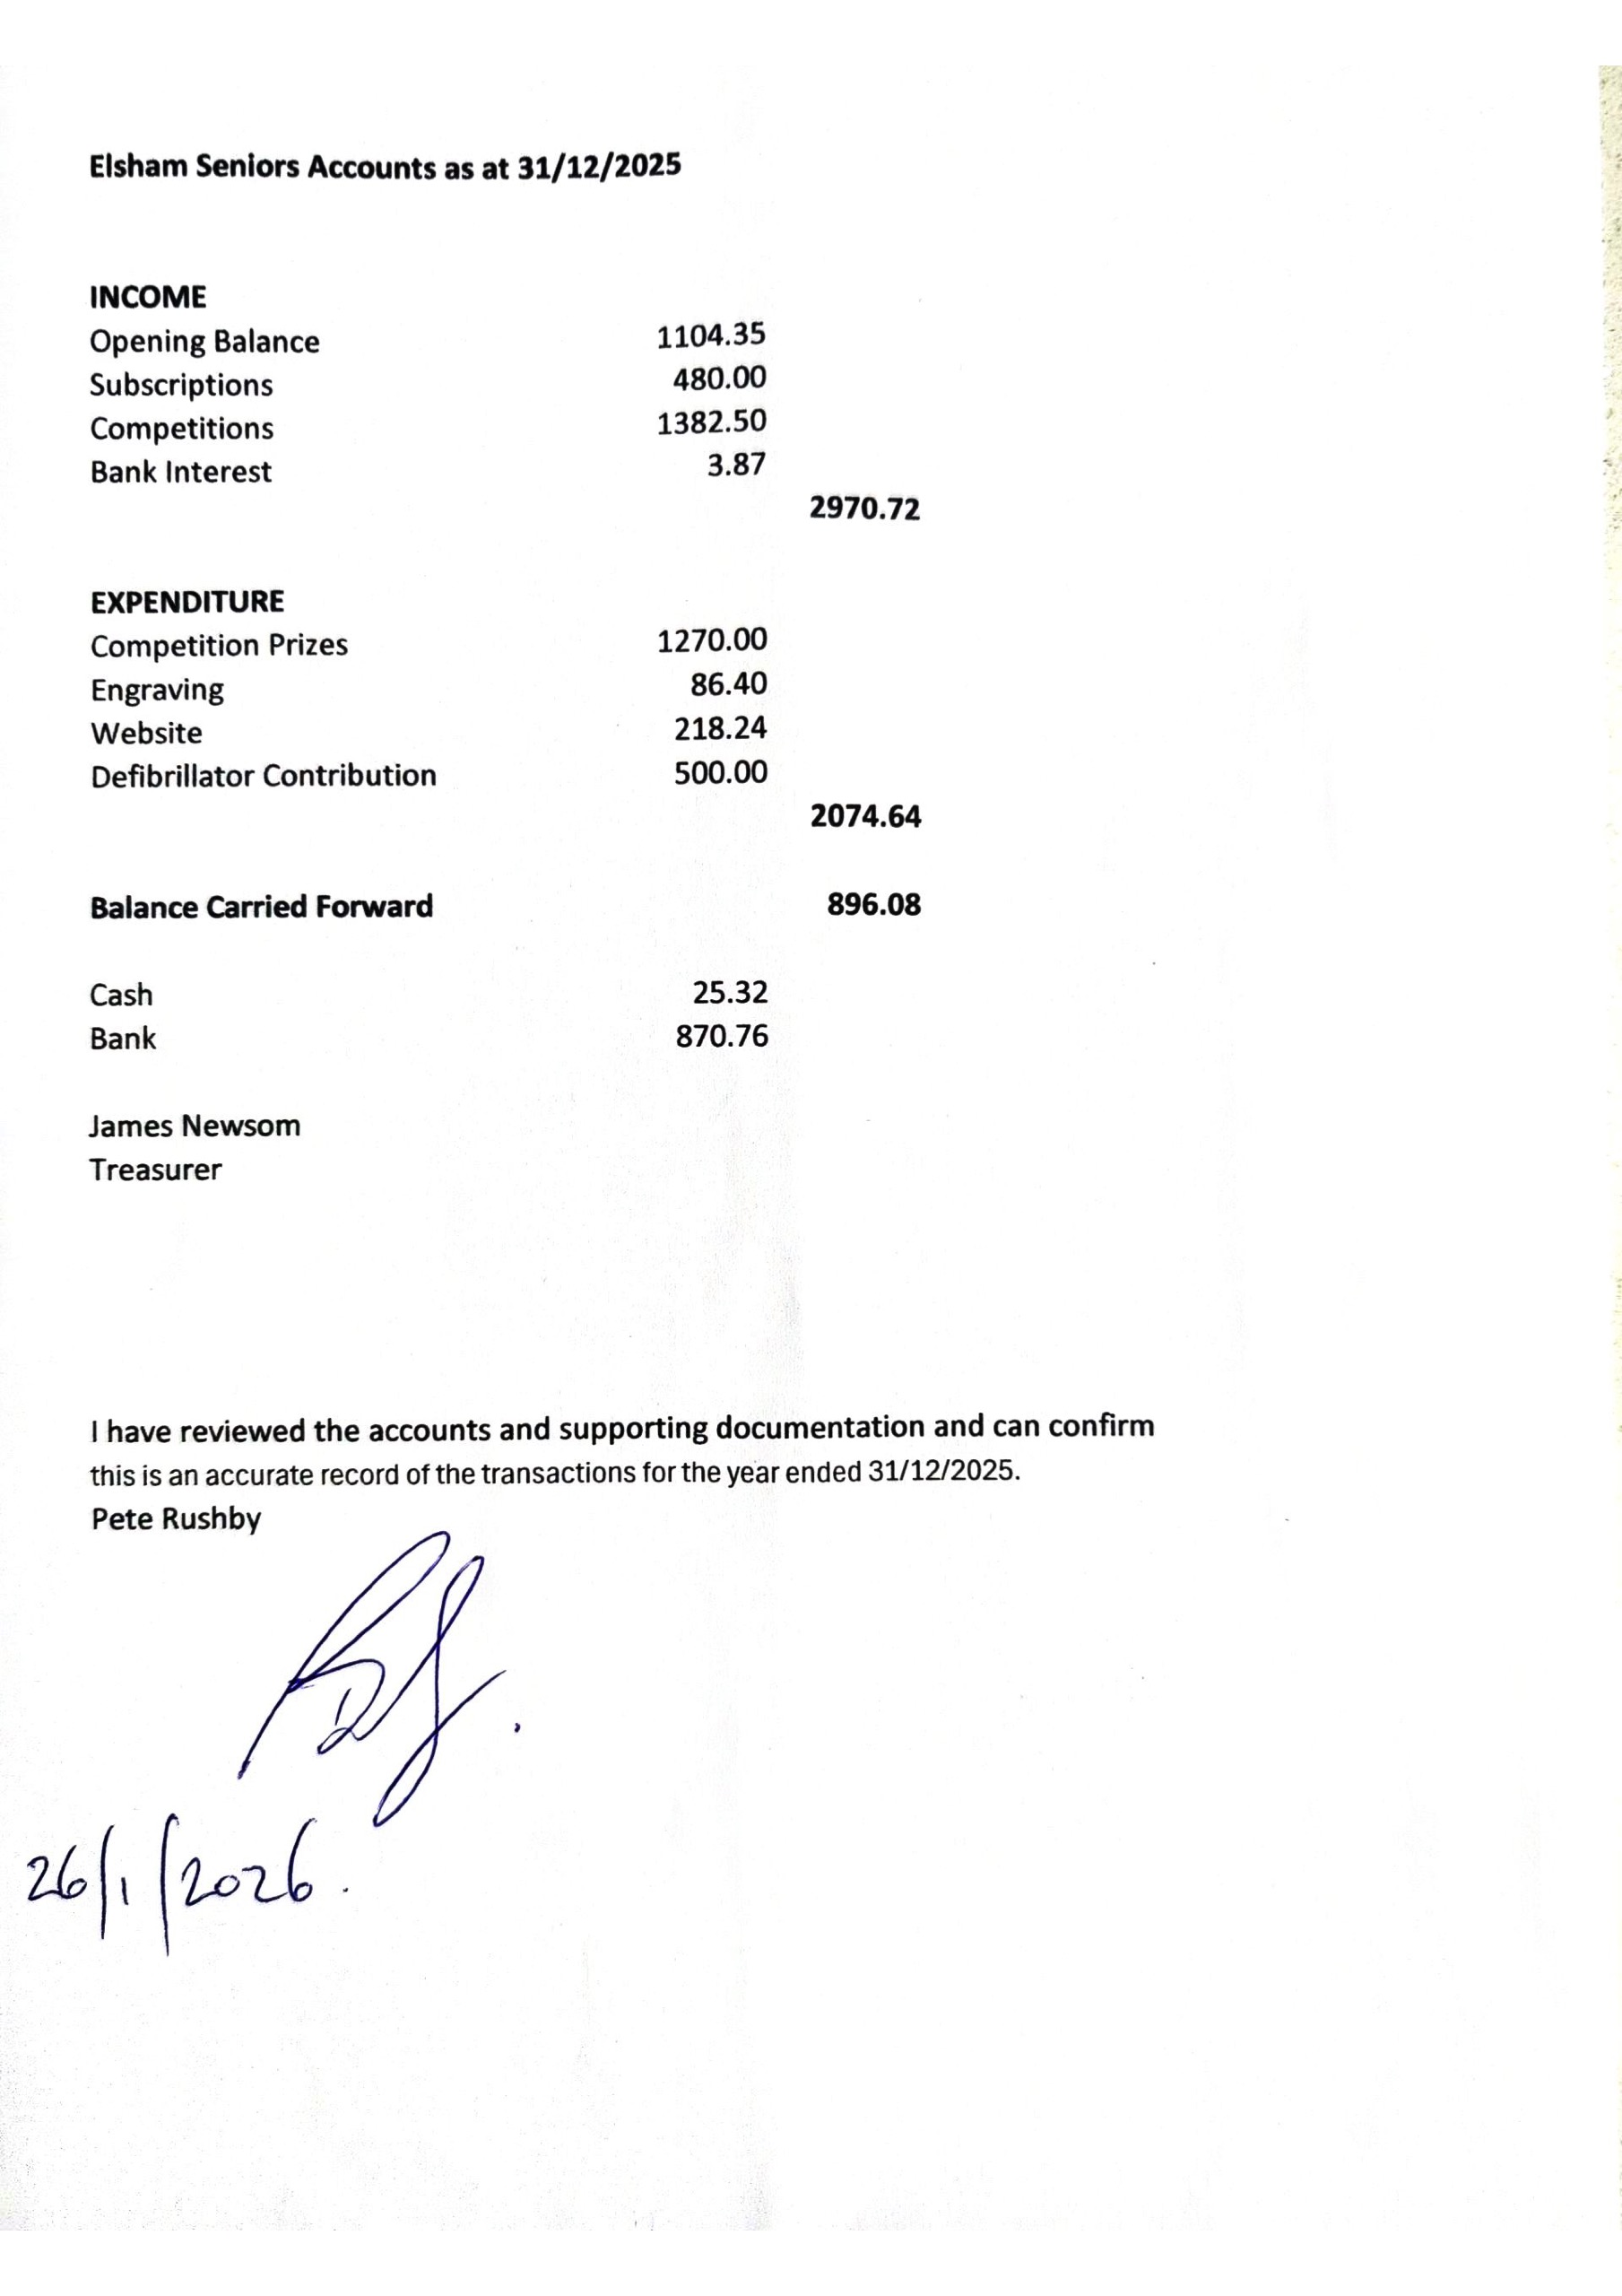

Appendix 4. to AGM MOM 250226
A Summary of General Discussion points.
A suggestion to run Internal Competitions on Mondays or Fridays rather than all on a Wednesday.This might allow greater participation. There was general agreement to the idea with the caution that the Annual Calendar is set in advance.
It was noted that the Secretary’s Job Description was available on the Seniors Website.
In general discussion of the Secretary’s role it became clear that the duties were not onerous and could be satisfied with only a few hours effort each month. Formats and templates and support from other Cttee members make the task relatively simple.
Consideration might also be given to arrangements that did not require the Secretary’s role.
It was noted that the website was currently out of date. WP advised that he was making efforts to remedy this. RM advised that the Cttee were considering more cost effective website solutions.
Consideration should be given to satisfactory catering supply for matches especially with the later start and finish times. It was noted that the later meal time might result in fewer wishing to take part with a loss in revenue to the clubhouse. JF was able to advise that the reaction from Away Teams had been good so far and RM advised that discussions with the catering dept were already underway and progressing well.
The Slow Play issue gave rise to much earnest and honest comment. There can be no doubt that the problem exists and must be addressed. There was considerable debate with various points of view expressed and agreement sought on a reasonable pace and how it can be achieved and maintained. Timing boards on the course were discussed and considered useful. It was noted that there is a responsibility to maintain contact with the match in front and if that is not achieved then to stand aside and allow others to play through. Course etiquette, ready golf and good practise was discussed and recommended. It was generally agreed that improvements were possible and would be sought.
It was reported that this issue was not solely a problem with Seniors... examples were given of similar issues in the Women’s and Men’s competitions.
It was noted that the continued allocation of a Seniors Roll Up on Seniors Match days might be considered a contributory or aggravating factor.
Senior Team Wear was discussed with a request that more modern alternatives were made available. RM was able to advise the meeting that discussions were already underway with the pro shop to this end and that more information would be available soon. It was noted that alternatives may well depend on a reasonable level of uptake from members.
The meeting concluded at 1520 with a general agreement that a move towards unity and tolerance within the group would be of benefit to all.

